**import array as arr**

**a = arr.array('i', [1, 2, 3])**

**print("The new created array is : ", end=" ")**

**for i in range(0, 3):**

**print(a[i], end=" ")**

**print()**

**b = arr.array('d', [2.5, 3.2, 3.3])**

**print("\nThe new created array is : ", end=" ")**

**for i in range(0, 3):**

**print(b[i], end=" ")**

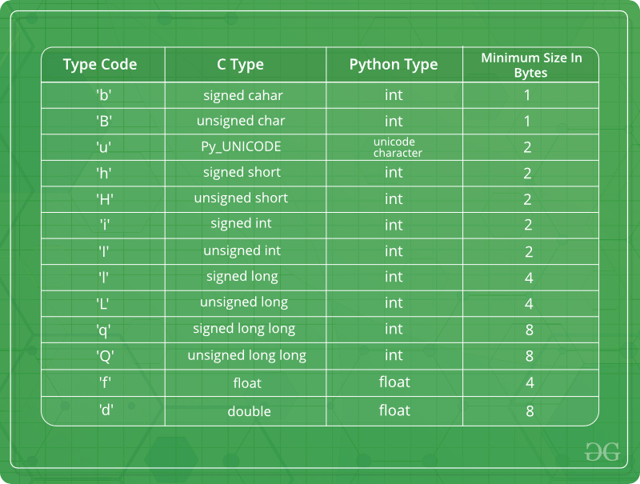

Adding elements in the array – using insert and append -

import array as arr

a = arr.array('i', [1, 2, 3])

print("Array before insertion : ", end=" ")

for i in range(0, 3):

print(a[i], end=" ")

print()

a.insert(1, 4)

print("Array after insertion : ", end=" ")

for i in (a):

print(i, end=" ")

print()

b = arr.array('d', [2.5, 3.2, 3.3])

print("Array before insertion : ", end=" ")

for i in range(0, 3):

print(b[i], end=" ")

print()

b.append(4.4)

print("Array after insertion : ", end=" ")

for i in (b):

print(i, end=" ")

print()

Accessing elements of the array-

import array as arr

a = arr.array('i', [1, 2, 3, 4, 5, 6])

print("Access element is: ", a[0])

print("Access element is: ", a[3])

b = arr.array('d', [2.5, 3.2, 3.3])

print("Access element is: ", b[1])

print("Access element is: ", b[2])

Removing elements from array –

import array

arr = array.array('i', [1, 2, 3, 1, 5])

print("The new created array is : ", end="")

for i in range(0, 5):

print(arr[i], end=" ")

print("\r")

print("The popped element is : ", end="")

print(arr.pop(2))

print("The array after popping is : ", end="")

for i in range(0, 4):

print(arr[i], end=" ")

print("\r")

arr.remove(1)

print("The array after removing is : ", end="")

for i in range(0, 3):

print(arr[i], end=" ")

Python Lambda –

A lambda function is a small anonymous function.

A lambda function can take any number of arguments, but can only have one expression.

x = lambda a : a + 10  
print(x(5))

x = lambda a : a + 10  
print(x(5))

Why lambda ?

def myfunc(n):  
  return lambda a : a * n  
  
mydoubler = myfunc(2)  
mytripler = myfunc(3)  
  
print(mydoubler(11))  
print(mytripler(11))